# Five Colleges MARC Record Loading

# NAXOS General Collection

## Collection Code: FCCNX

## Files

Files comes through UMass OCLC Contract Services. These files are encoded as MARC 8. Use the transformation of MARC to UTF-8. As these files are done through a contract with OCLC, there is no collision as with other OCLC KB collections. The file can be taken as is.

## Preprep Files

No preparation is necessary. Only check the file to ensure it is UTF-8.

## Outline

1. Download file and check for correct UTF-8 encoding
2. Convert the file
3. Run the fix
4. Check the database
5. Troubleshoot any multimatches
6. Load records
7. Generate the record keys
8. Run the fix in FCL60
9. Run the Global update in FCL01

## Process

### Retrieve MARC File(s)

The files are downloaded from OCLC Collection Manager.

### Load Records into Alpeh

1. FTP file to /exlibris/aleph/u21_1/fcl01/scratch directory
2. (Step 1) Services/Load Catalog Records and Convert step 1 (file-01)
   1. Input file: name of the marc file
   2. Output file: any name
   3. MARC Record Format: ‘1D’ separator
   4. Library: FCL01

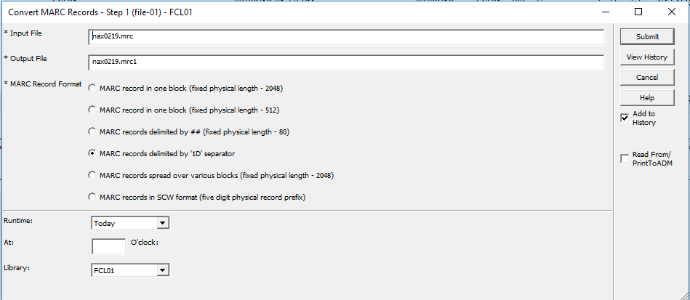

1. (Step 2) Click on Services/Load Catalog Records and Convert step 2 (file -02)
   1. Input file: name of output file from step 1
   2. Output file: new name
   3. MARC Record Form: Marc Record
   4. Library: FCL01

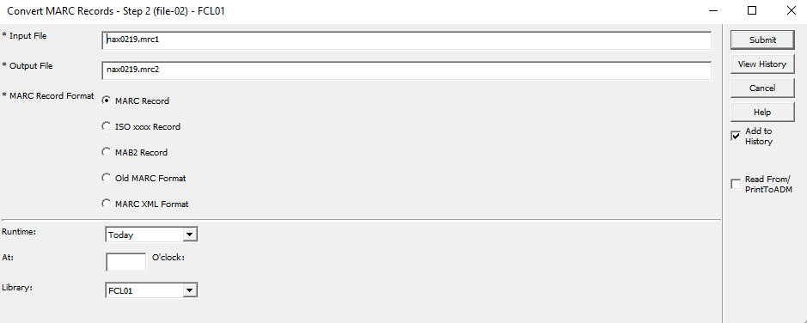

1. (FIX) Services/Load Catalog Records and select Fix Catalog Records (manage-37)
   1. Input File: Name of output file from step 2
   2. Output file: New name
   3. Input File Type: ALEPH Sequential
   4. Fix Routine: UMNAX
   5. Update Database: No

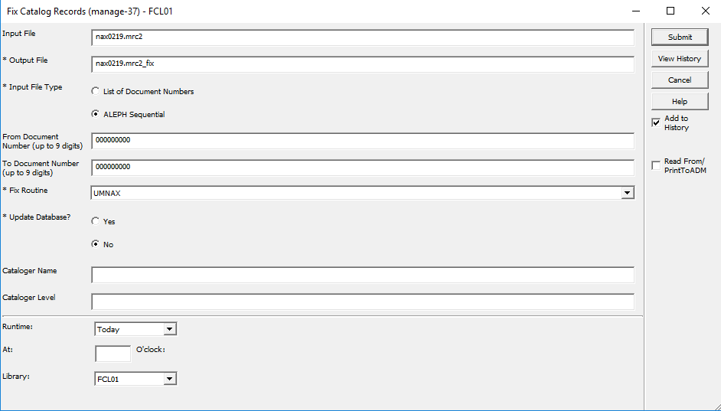

1. (Check Database) Services/Load Catalog Records and select Check Input File Against Database (manage-36)
   1. Input file: Name of output file from manage-37
   2. Output file 1, 2 & 3: give numbers 0 (new or no matches), 1 (update or single match), 2 (multimatches)
   3. Match Selection: 0359A
   4. Tag for Multiple Record Numbers: 989 or some other field never used
   5. Library: FCL01

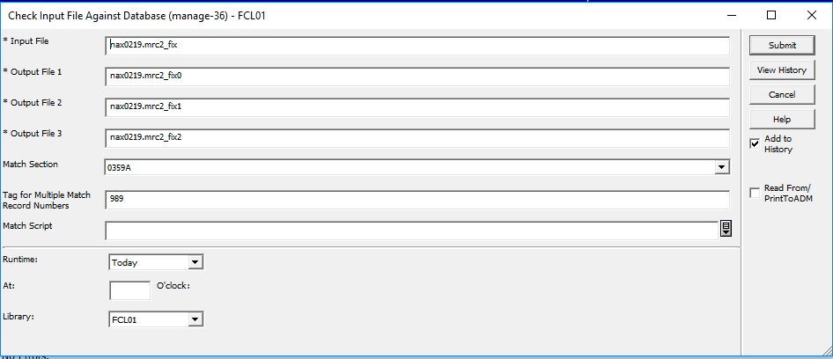

1. (**NEW & Updated RECORDS LOAD**): There is data in the file with the 0 at the end. Load that file under Services/Load Catalog Records and select Load Catalog Records (manage-18)
   1. Input file: File name with 0 at the end from manage-36
   2. Output file for Rejected Records: Add new file name
   3. Output file for Logging System Numbers: Add new file name
   4. Procedure to Rune: Add new records to the database
   5. If Updating Current Records: Replace fields within a record
   6. Indexing: Full
   7. Fix Routine: None
   8. Merge/Preferred Routine: None
   9. Character Conversion: MARC8_TO_UTF (**NOTE: Naxos Only Provides a MARC8 file)**
   10. No. of Catalogers Currently Working: Multi-users
   11. Library: FCL01

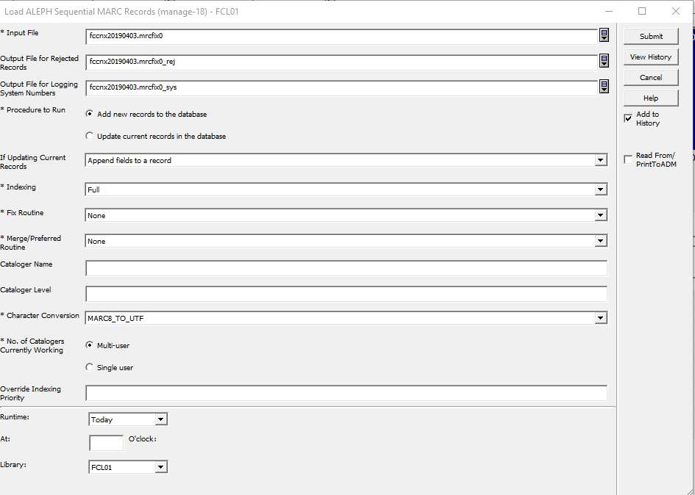

1. **(Add Inventory for Records)** Add Items/Holdings for New Records Loaded. Go to Serves/Load Catalog Records and select Create Holdings and Item records based on Bibliographic Data (manage-50)
   1. Input file: File name for the list of bib sys numbers created in last step manage-18
   2. ADM Library: DEP50
   3. HOL Library: FCL60
   4. Expand Procedure: None
   5. Main Field: 949#1
   6. Item/Holdings Creation Table: tab_hol_item_create_fccgen
   7. Mapping table: tab_hol_item_map_fccnx
   8. Holdings Record Creation Mode: Create holdings records if none already exist
   9. Item Record Creation Mode: Create holdings records if none already exist
   10. Holdings/Item Creation Interaction: Create holdings records based only on new items
   11. ADM Cataloger: Your login username to Aleph
   12. ADM Cataloging Level: 20
   13. HOL Cataloger: Your login username to Aleph
   14. HOL Cataloging Level: 20
   15. Update Database: Yes
   16. Check Item records: Yes
   17. Library: FCL01

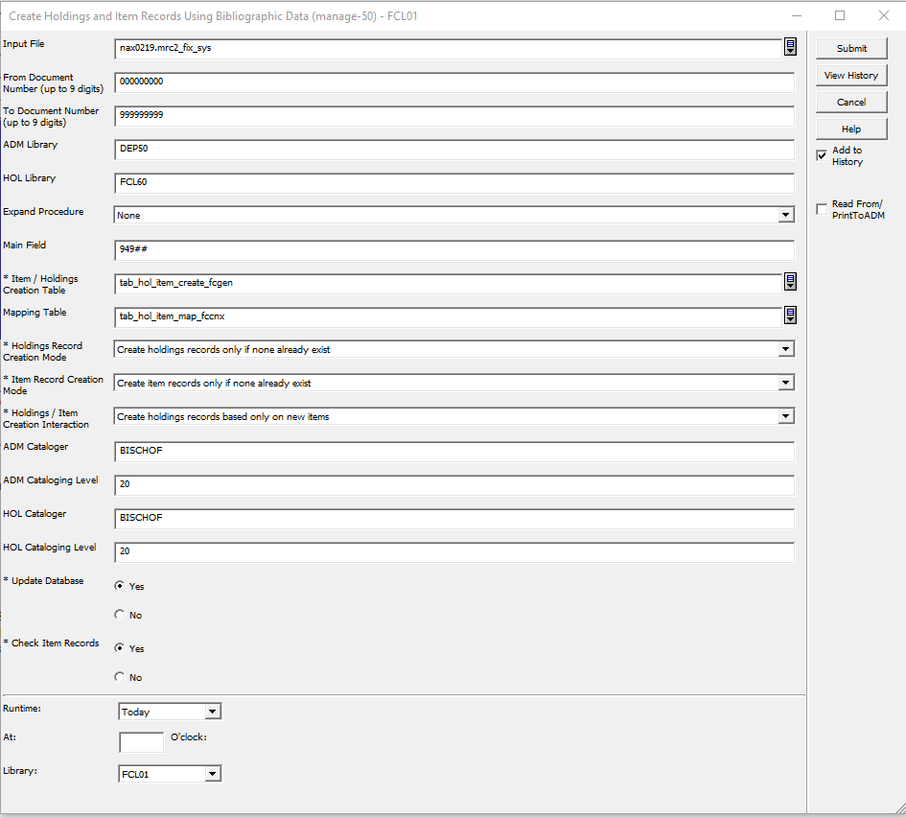

1. In FCL01, Services/General/Retrieve Record Keys (manage_70)
   1. Input file: your file with the system numbers
   2. Output file: any file name
   3. Convert Type: BIB-TO-HOL
   4. Convert Library: FCL01
   5. Library: FCL60

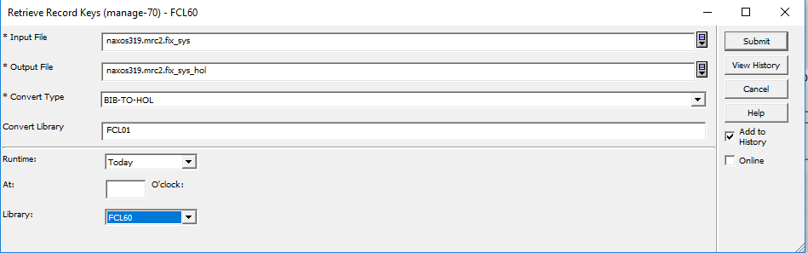

1. In FCL60, Services/Load Catalog Records/Fix Catalog Records (manage_37)
   1. Input file: name of the Output file from 8 above
   2. Output file: any file name for the system numbers
   3. Input File Type: List of Document Numbers
   4. Library: FCL60

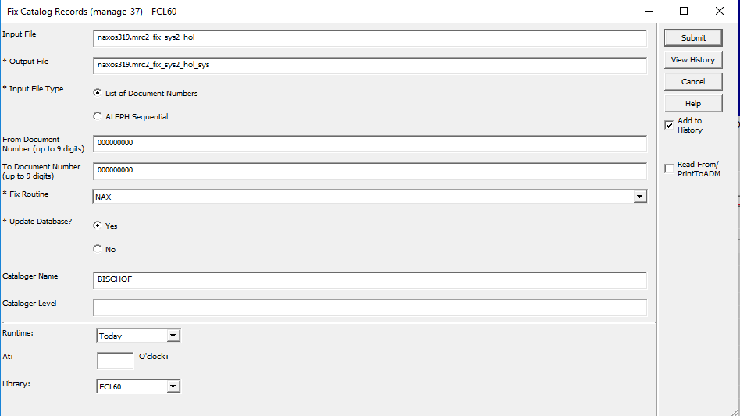

1. In FCL01, Services/Catalog Maintenance Procedures/Global Updates (manage_21)

